SEX | COLOUR | DATE OF BIRTH (DD/MM/YYYY) | SIRE | DAM | REGISTERD NAME

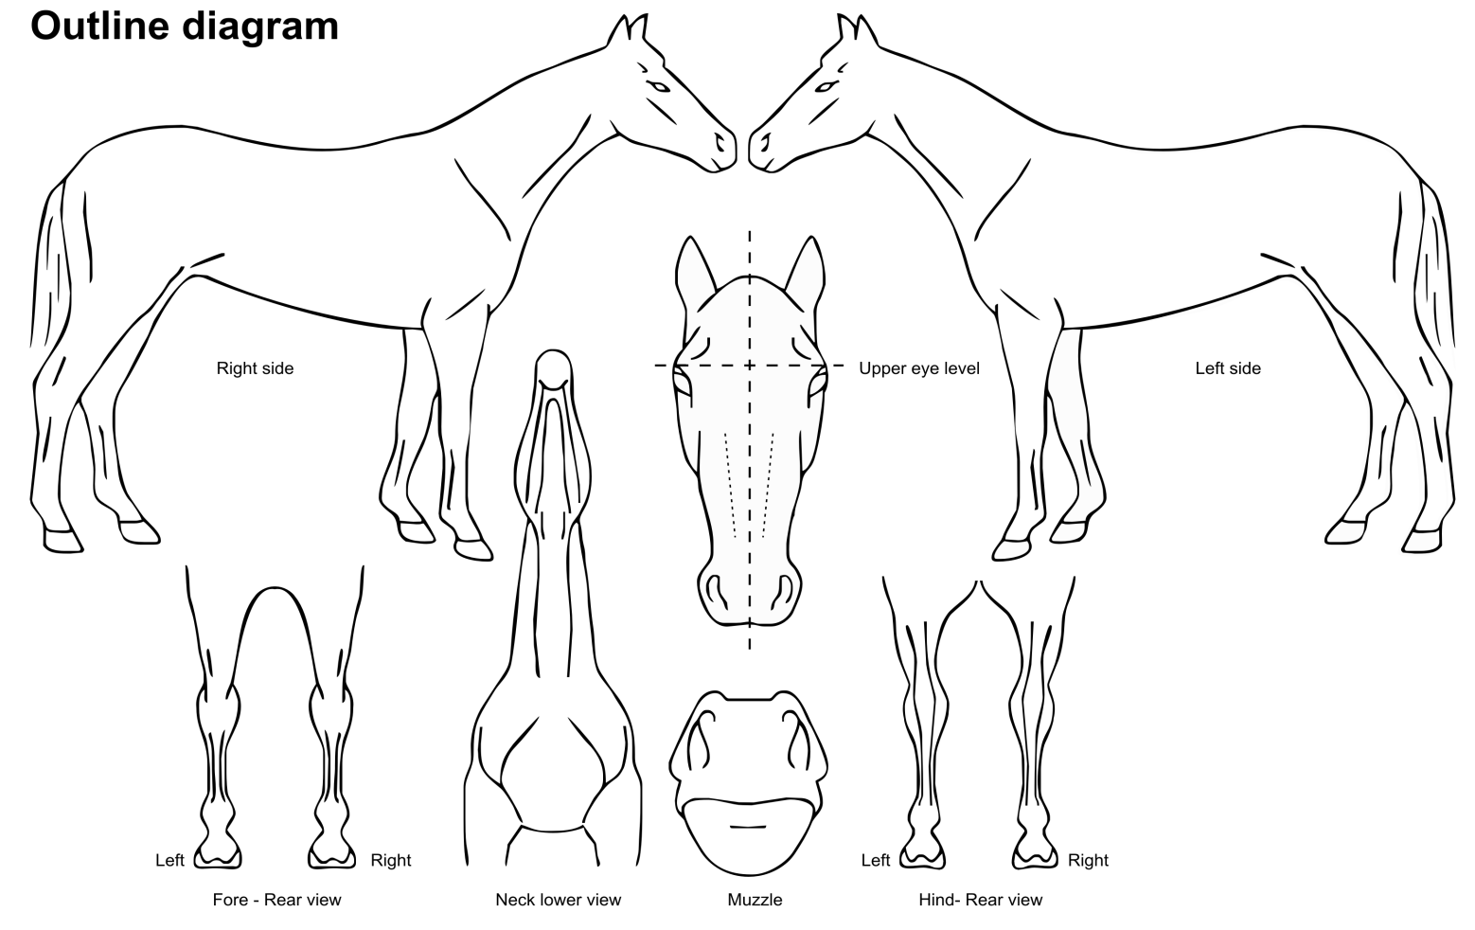 | MICROCHIP STICKER  NAME OF VETERINARIAN  ________________________________  ________________________  SIGNATURE OF VETERINARIAN  DATE____/______/_________  PRACTICE STAMP
WRITTEN DESCRIPTION OF MARKINGS:
HEAD: __________________________________________________________________________________________________________________________________________________

LEFT FORE |  |  | BODY / WHORLS
RIGHT FORE
LEFT HIND
RIGHT HIND

ACQUIRED (BRAND/FREEZE MARKS OR PERMANENT SCARS)__________________________________________________________________________________________________

